Blade Pitch
Pitch is changed hydraulically in a single-acting system, using engine oil controlled by the propeller governor to change the pitch of the propeller blades. In constant-speed systems, the pitch is increased with oil pressure. In full-feathering systems, the pitch is decreased with oil pressure. To prevent accidentally moving the propellers to the feathered position during powered flight, which would overload and damage an engine that is still running, the controls have detents at the low RPM (high pitch) end.
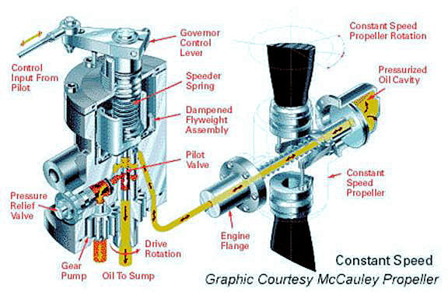
In a single-acting propeller system, oil pressure supplied by the governor, acting on the piston produces a force that is opposed by the natural centrifugal twisting moment of the blades in constant speed models or counterweights and large springs in full-feathering systems. To increase or decrease the pitch, high pressure oil is directed to the propeller, which moves the piston back. The motion of the piston is transmitted to the blades through actuating pins and links, moving the blades toward either high pitch for constant-speed systems or low pitch for full-feathering systems.
When the opposing forces are equal, oil flow to the propeller stops and the piston also stops. The piston will remain in this position, maintaining the pitch of the blades until oil flow to or from the propeller is again established by the governor.
From this position, pitch is decreased for constant-speed systems or increased for full- feathering systems by allowing oil to flow out of the propeller and return to the engine sump. When the governor initiates this procedure, hydraulic pressure is decreased and the piston moves forward, changing the pitch of the blades. The piston will continue to move forward until the opposing forces are once again equal. Mechanical stops are installed in the propeller to limit travel in both the high and low pitch directions.
Full-Feathering vs. Constant Speed
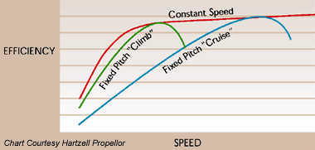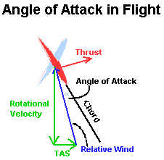
A constant-speed (RPM) system permits the pilot to select the propeller and engine speed for any situation and automatically maintain that RPM under varying conditions of aircraft attitude and engine power. Thereby permitting operation of propeller and engine at most efficient RPMs. RPM is controlled by varying the pitch of the propeller blades - that is, the angle of the blades with relation to the plane of rotation. When the pilot increases power in flight, the blade angle is increased, the torque required to spin the propeller is increased and, for any given RPM setting, aircraft speed and torque on the engine will increase. For economy cruising, the pilot can throttle back to the desired manifold pressure for cruise conditions and decrease the pitch of the propeller, while maintaining the pilot-selected RPM.
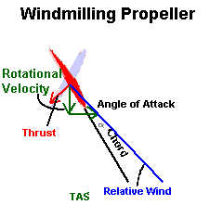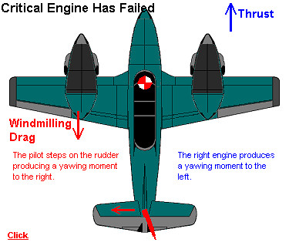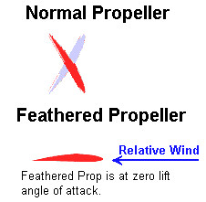
A full-feathering propeller system is normally used only on twin-engine aircraft. If one of the engines fails in flight, the propeller on the idle engine can rotate or windmill, causing increased drag. To prevent this, the propeller can be feathered (turned to a very high pitch), with the blades almost parallel to the air stream. This eliminates asymmetric drag forces caused by wind milling when an engine is shut down. A propeller that can be pitched to this position is called a full-feathering propeller.
Blade Performance
Shape of Propeller Tips
Propeller tips can be rounded, swept or square. Various tips are often used to meet blade vibration resonance or special design conditions. Tip shape is also a function of aesthetics, noise requirements, flight performance and ground clearance.
Propeller Diameter
Propeller diameters are a function of engine and airframe limitations. Larger propeller diameters are preferred for low airspeed operation, while smaller diameters are best for high airspeeds. For example, the diameter of a fixed-pitch propeller is often large to favour low airspeed operation, while the blade size is small to favour higher airspeeds and faster turning at low airspeeds. The diameter and blade size of a constant-speed propeller is often larger (than a fixed-pitch), due to the variability of blade angles.
Engine Horsepower and RPM
For fixed-pitch props, at a fixed throttle setting, propeller and engine RPM increases or decreases with the airspeed. At a constant airspeed, fixed-pitch propeller and engine RPM change if power is increased or decreased. A constant-speed prop uses a governor to provide constant RPM at the selected throttle setting. The blade angle automatically increases or decreases as the RPM setting or engine power changes. With a fixed RPM and power setting, the blade angle automatically changes as airspeed increases or decreases.

